**SHEET -3 -FILE PERMISSIONS AND FILE LINKS**

1. List all the files and directories in your user directory

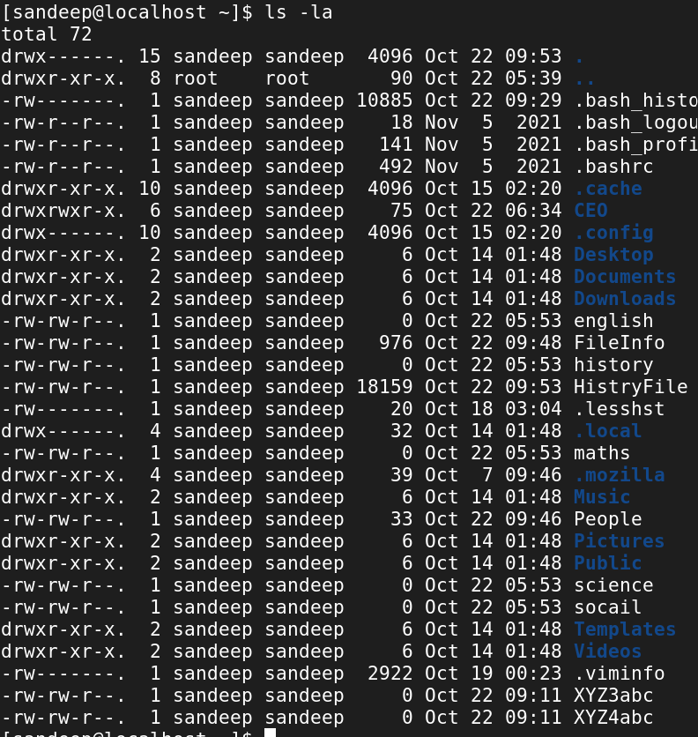

1. Observe the permission for each file and directories.
2. For Directory give the following permission using chmod cmd
3. VP Sales
4. User – rwx ii. Group – r-x iii. Others – r- -

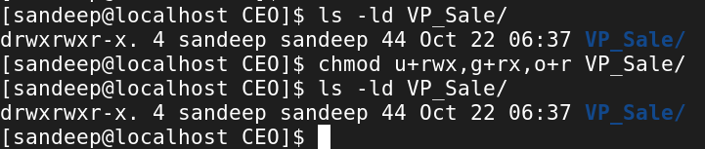

1. People i. User – r - - ii. Group – r- - iii. Others – r- -

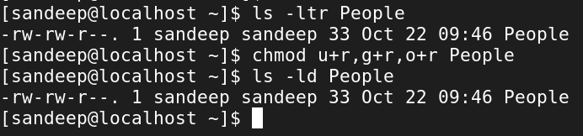

1. Sales Rep i. User – r - - ii. Group – - - - iii. Others – r- -

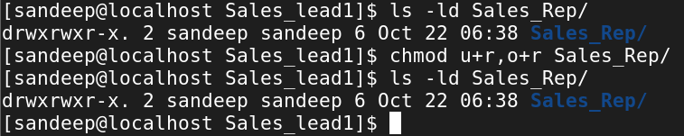

1. For Directory give the following permission using chmod cmd using Numeric values
2. Product Lead i. User – -wii. Group – rwx iii. Others – rwx

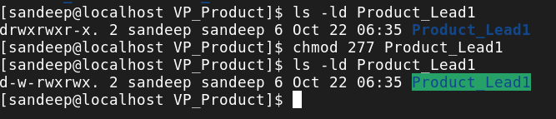

1. Senior Developer i. User –rwx ii. Group – rwiii. Others – --x

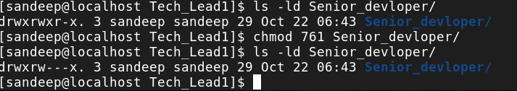

1. Tech Lead i. User – r - x ii. Group – r- x iii. Others – rwx

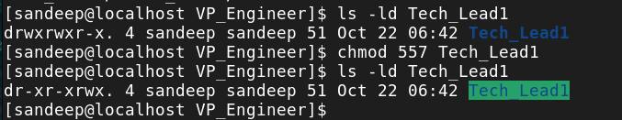

7. Create a file – **SoftLinkTest** under your user directory, input some text and **cat** it to display its contents.

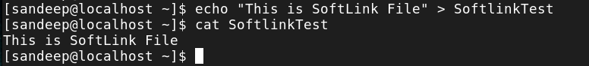

8. Repeat the same for file – HardLinkTest.

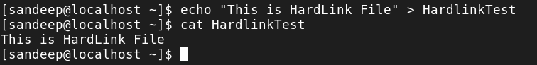

9. Create softlink for file SoftLinkTest under /tmp directory using ln-s cmd

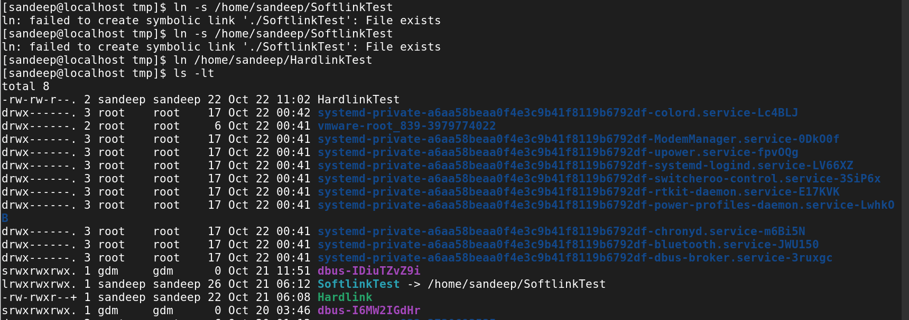

11. Check the **inodes** for each file and its link

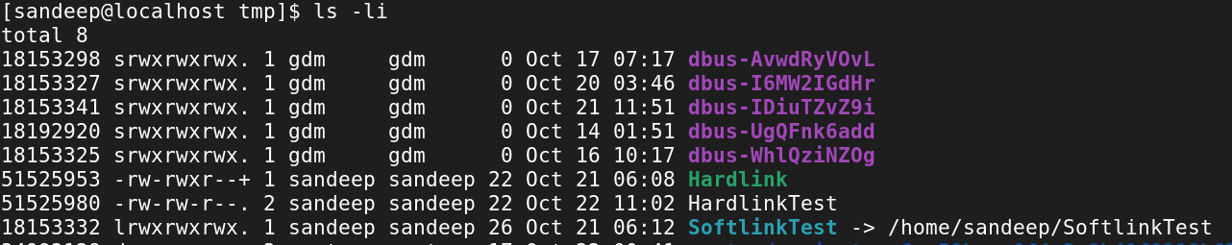

12. **Update** the file **contents** and observe the changes

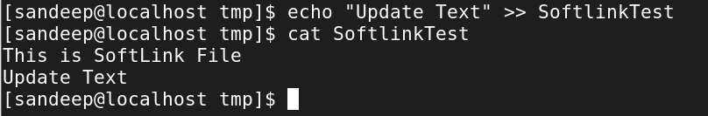

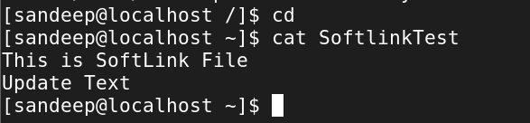

13. **Delete** the **files** and observe the changes

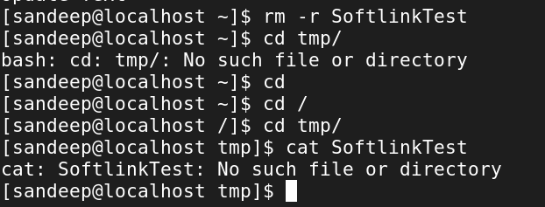

14. Create a **hard** and **soft link** for a directory of your choice and record the results.

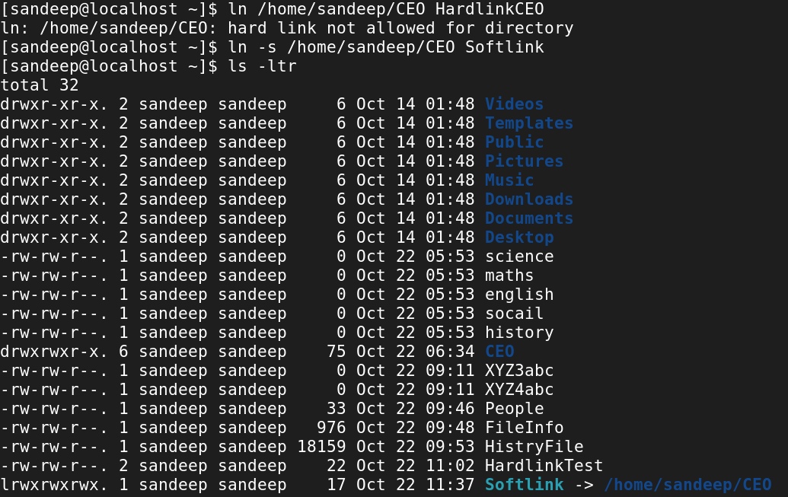

15. Use cp cmd to copy a directory of your choice into CEO directory. Try with **empty** as well as with **sub directories**.

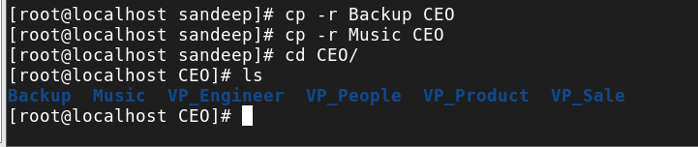

16. Go to /var/log, display the contents of file messages using **more** and **less**, **head** and **tail** cmd

17. Go to /bin, run cmd **ls -l** | more

18. Go to /bin, run cmd **ls -l** | less

19. Go to /bin, run cmd **ls -l** | head

20. Go to /bin, run cmd **ls -l** | tail

21. Run **head** and **tail** cmd to get specified number of lines displayed eg. head -5, tail -3 etc.

